EMBEDDED SYSTEM AUTOMATION

**23SDEC02A**

A.Y: 2024 –25

Semester: II/IV – Even Sem



DEPARTMENT OF ELECTRONICS AND

COMMUNICATION ENGINEERING

## Vaddeswaram, Guntur District

**Name of the Student :**

**Roll number :**

|  |  |  |  |  |
| --- | --- | --- | --- | --- |
| **INDEX OF EXPERIMENTS** | | | | |
| **S. No.** | **Name of the Experiment** | **Page No.** | **Marks** | **Faculty Sign** |
| 1. | Reading the default clock rate of ESP 32 Microcontroller. |  |  |  |
| 2. | Interrupt handling of ESP 32 Microcontroller. |  |  |  |
| 3. | Timer and Interrupt of ESP 32 Microcontroller. |  |  |  |
| 4. | Serial Communication between Two ESP 32. |  |  |  |
| 5. | I2C Device Scanning using ESP 32. |  |  |  |
| 6. | Testing of I2S microphone using ESP 32. |  |  |  |
| 7. | Finding the Default SPI pins of ESP 32. |  |  |  |
| 8. | Interfacing MCP 2515 CAN controller with ESP 32. |  |  |  |
| 9. | ADC read using LED dimmer using ESP 32. |  |  |  |
| 10. | Observation of Analog output from ESP 32. |  |  |  |
| 11. | Sine wave Generation using ESP 32. |  |  |  |
| 12. | Testing of EEPROM memory of ESP 32. |  |  |  |
| 13. | Scanning Bluetooth Devices using ESP 32. |  |  |  |
| 14. | Duplex Bluetooth Communication Between ESP 32 and Android Phone. |  |  |  |
| **S. No.** | **Name of the Experiment** | **Page No.** | **Marks** | **Faculty Sign** |
| 15. | Scanning of Wi-Fi Network using ESP 32. |  |  |  |
| 16. | Signal Strength Identification of Wi-Fi Network using ESP 32. |  |  |  |
| 17. | Get and Set MAC address of ESP 32. |  |  |  |
| 18. | Get the IP address of ESP 32. |  |  |  |
| 19. | Assign Static IP address for ESP 32. |  |  |  |
| 20. | Change the host name of ESP 32. |  |  |  |
| 21. | Controlling the GPIO pins in ESP32 using Touch Inputs |  |  |  |

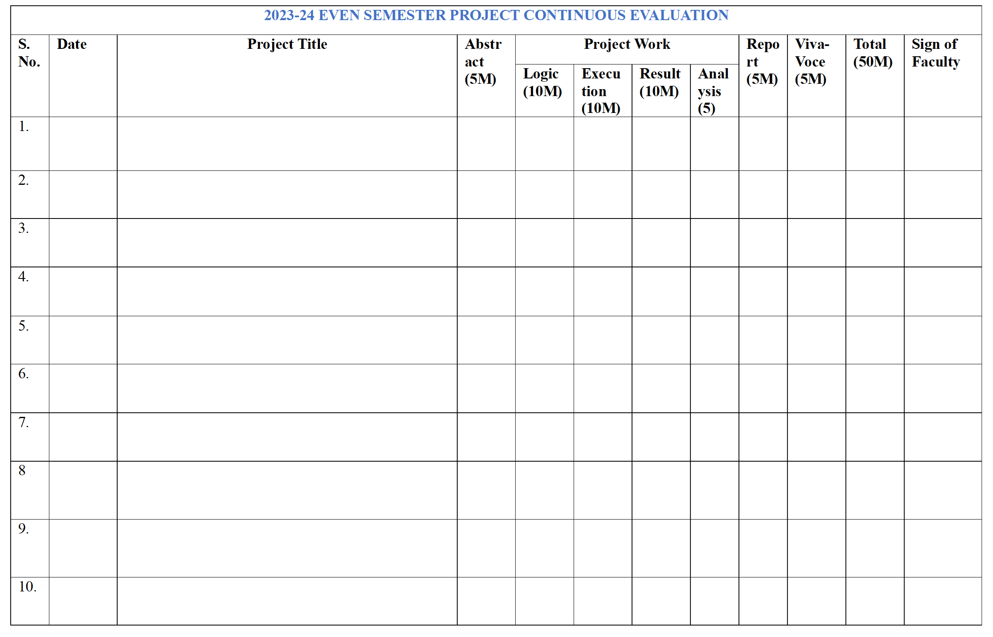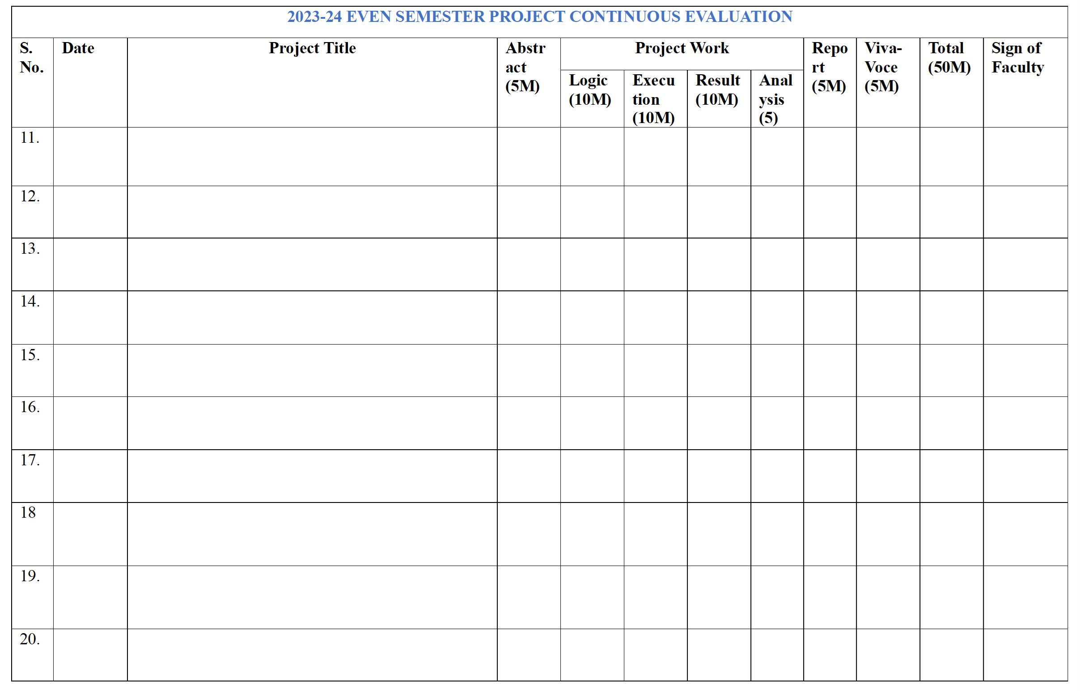

**Session 01: Reading the default clock rate of ESP 32 Microcontroller**

**Date of the Session: / /**  **Time of the Session****: to**

**PREREQUISITE:**

* General idea of clock frequency, ESP32 board
* General idea of basic circuit

**PRE-LAB:**

1. What is the role of the CPU clock speed in a microcontroller like the ESP32?
2. What is the default CPU clock speed of the ESP32, and how can it be configured?

**OBJECTIVE:**

To design and implement a serial communication port, checks the CPU clock rate & XTAL Freq & APB bus clock.

**COMPONENTS REQUIRED:**

* ESP32
* Breadboard
* Jumper Wires Pack
* Micro usb cable

**THEORY:**

**ESP32 CPU Speed (Frequency):**

The ESP32 is a dual-core system with two Harvard Architecture Xtensa LX6 CPUs. All embedded memory, external memory, and peripherals are located on the data bus and/or the instruction bus of these CPUs.

**CPU Clock:**

Both CPUs can be clocked from various sources internally or externally. The most important circuitry is the PLL (Phase-Locked Loop) which multiplies the input clock frequency (whether it’s an external crystal or internal oscillator). This results in a much higher frequency signal that’s derived from the main clock source (orders of magnitude in terms of frequency).

The PLL_CLK is an internal PLL clock signal with a frequency of 320 MHz or 480 MHz. Note that this PLL clock is divided /2 or /4 before it’s fed to any CPU. The table down below from the datasheet shows the possible configurations for the clock.

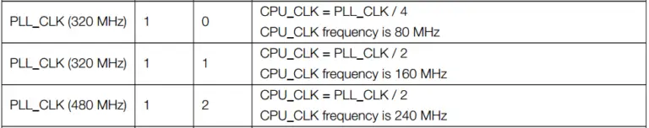

**Peripherals Clock:**

The APB bus clock (APB_CLK) is derived from CPU_CLK, the division factor depends on the CPU_CLK source as shown in the table down below. The peripherals clock signals are APB_CLK, REF_TICK, LEDC_SCLK, APLL_CLK, and PLL_D2_CLK.

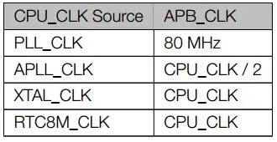

With that being said, we can conclude that setting the PLL_CLK as a clock source will help us choose the 480MHz PLL clock output as a clock source for the CPU (the CPU_CLK will be 480/2 MHz). While the APB bus will be clocked @ 80MHz due to this option being selected.

**CIRCUIT:**

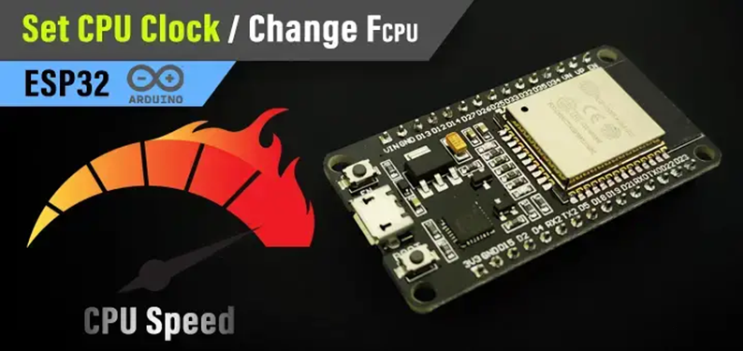

**ESP32:**

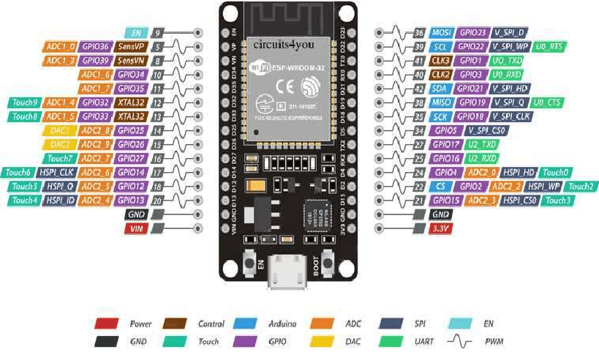

**CODE:**

**PROCEDURE:**

1. Choose the board, COM port, hold down the BOOT button, click upload and keep your finger on the BOOT button pressed.
2. When the Arduino IDE starts sending the code, you can release the button and wait for the flashing process to be completed.
3. Now, the ESP32 is flashed with the new firmware.

**OUTPUT:**

**POST LAB:**

**INTERFERENCE & ANALYSIS**

**RESULT**

**Session 02: Interrupt handling of ESP 32 Microcontroller**

**Date of the Session: / / Time of the Session: to**

**PREREQUISITE:**

* General idea of Interrupts, ESP32 board
* General idea of basic circuit

**PRE-LAB:**

1. What is the primary purpose of external interrupts in microcontroller development, such as the ESP32?
2. Explain the concept of an external interrupt trigger type. How does it influence the interrupt behaviour?

**OBJECTIVE:**

* To Define an output pin (for the LED)
* Define an input pin & Attach interrupt to it
* Write the ISR function to toggle the LED pin on each RISING edge

# **COMPONENTS REQUIRED:**

* ESP32
* Breadboard
* Jumper Wires Pack
* Micro USB Cable

**THEORY:**

**Interrupt Latency:**

Interrupt latency is the time it takes the CPU to respond to a specific interrupt signal. It’s a measure for the response time of an interrupt and it’s desired to be as small as possible. Upon an interrupt signal reception, the CPU suspends the current main code executions, saves the context, switches the context to the ISR, executes the ISR code, switches the context back to main, and finally resumes the main code execution.

This takes some time and it’s desired to be as small as possible. The time between the hardware interrupt signal and the start of ISR execution (interrupt latency) is what we’re going to measure in this LAB.

**CIRCUIT:**

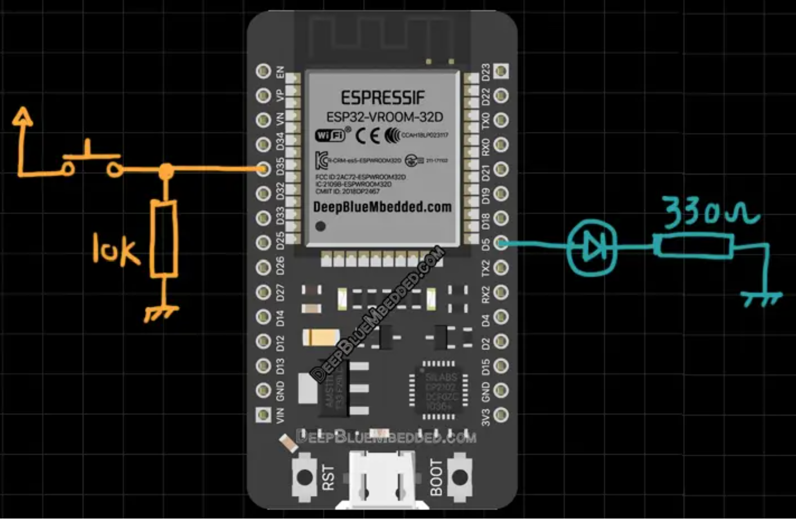

**ESP32:**



**CODE:**

**PROCEDURE:**

1. Choose the board, COM port, hold down the BOOT button, click upload and keep your finger on the BOOT button pressed.
2. When the Arduino IDE starts sending the code, you can release the button and wait for the flashing process to be completed.
3. Now, the ESP32 is flashed with the new firmware.

**OUTPUT:**

**POST LAB:**

**INTERFERENCE & ANALYSIS**

**RESULT**

**Session 03: Timer and Interrupt of ESP 32 Microcontroller**

**Date of the Session: / / Time of the Session: to**

**PREREQUISITE:**

* General idea of Timer, ESP32 board
* General idea of basic circuit

**PRE-LAB:**

1. What is the primary purpose of timers in microcontroller development, such as the ESP32?
2. Explain the difference between hardware timers and software timers on the ESP32.

**OBJECTIVE:**

* Generate Timer Interrupt events in Arduino IDE.

**COMPONENTS REQUIRED:**

* ESP32
* breadboard
* Jumper Wires Pack
* Micro USB Cable

# **THEORY:**

**ESP32 Timers & Timer Interrupts (Arduino IDE):**

In this tutorial, you’ll learn how to use ESP32 internal Timers & generate Timer Interrupt events in Arduino IDE. We’ll discuss how ESP32 Timers work, how to configure ESP32’s Timers, and how to generate periodic interrupts to synchronize the execution of logic within your project. And also measure the timer between two events whether they’re external or internal events.

**ESP32 Timers:**

The ESP32 SoCs come with 4 hardware timers, each of which is a general-purpose 64-bit up/down counter with a 16-bit prescaler. Except for ESP32-C3 which has only 2 timers each of which is 54 bits instead. The ESP32 timers have the capability of auto-reloading at the end of the counting period as well.

**ESP32 Timers Functional Description:**

Each ESP32 timer uses the APB clock (APB_CLK which is normally 80 MHz in frequency) as a base clock. This clock is then scaled downby a 16-bit prescaler which generates the time-base tick time. Therefore, we’ll be changing the value of the prescaler in order to control the timer tick time.

The 16-Bit prescaler can divide the APB_CLK by a factor from 2 to 65536. When you set the prescaler value to be either 1 or 2, the clock divisor is 2; when you set the prescaler to 0, the clock divisor is 65536. Any other value will cause the clock to be divided by exactly that value that you’ve written to the prescaler register.

**ESP32 Timers Alarm Generation:**

ESP32 timers can trigger an alarm (Event) which will cause a timer to reload and/or interrupt to occur, depending on your configuration. The alarm event is triggered when the value you’ve stored in the alarm register matches the current timer value. This is very useful to set periodic interrupts to execute some pieces of logic periodically in your project as we’ll be doing hereafter.

**ESP32 Timers Equation:**

In order to generate periodic events with ESP32, we’ll be using the alarm event generation as well as the timer’s prescaler in order to achieve the desired interrupt periodicity. There are 3 special cases for the Timer equation down below, which are when the prescaler value is = 0,1, and 2. When **Prescaler=1or2,** it’s going to be as follows **[ TOUT = TimerTicks x (2/APB_CLK) ].** When **Prescaler=0**, it’s going to be as follows **[ TOUT = TimerTicks x (65536/APB_CLK) ].** Otherwise, we can generally use the equation down below.

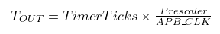

**ESP32 Timer Example (Arduino):**

Let’s say we’d like to toggle an LED every 1 ms without using a **delay** that blocks the CPU and does much harm to the overall timing performance of your system. For this, we’ll use the timer’s equation above, Given that the default **APB_CLK** is **80MHz** or 80,000,000Hz. The desired **TOUT** for the interrupt period in which we’ll toggle the LED is 1ms, So **TOUT** = **1ms or 0.001s**. The only two unknowns now are the Prescaler value and the TimerTicks count which we’ll set the alarm event to.

We can set the Prescaler to whichever value we want but for the sake of simplifying the calculations, let’s set the **Prescaler=80**. This will leave us with only one unknown which is the **TimerTicks** count. So, we’ll solve the equation for TimerTicks:

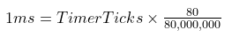

# **CIRCUIT:**

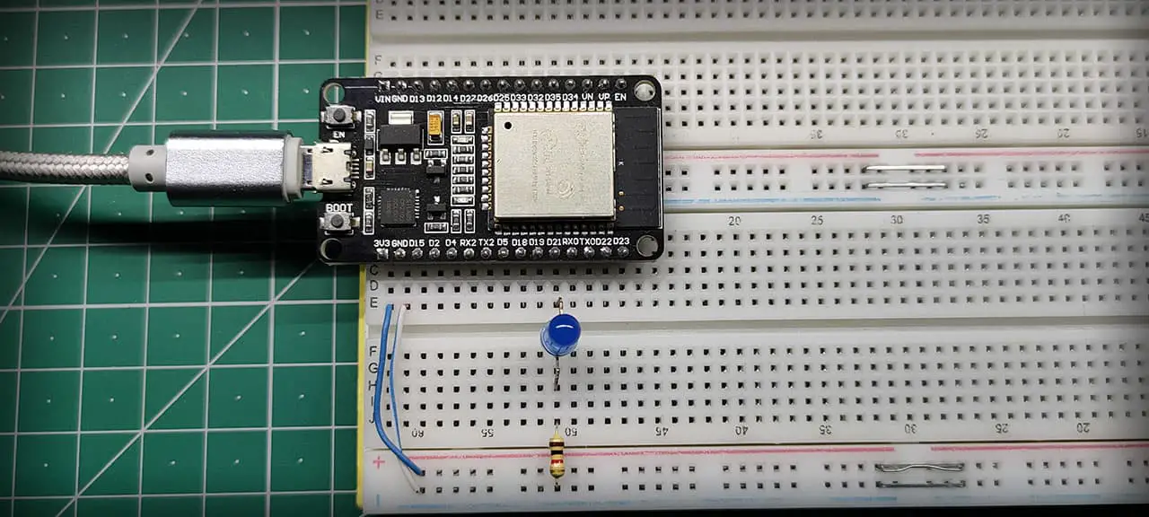

**ESP32:**



**CODE:**

**PROCEDURE:**

1. Set Timer0 to generate a periodic interrupt each 50ms
2. In Timer0_IRS() which runs every 50ms, do a LED toggle
3. Keep repeating…

**OUTPUT:**

**POST LAB:**

**INTERFERENCE & ANALYSIS**

**RESULT**

**Session 04: Serial Communication between Two ESP 32**

**Date of the Session: / / Time of the Session: to**

**PREREQUISITE:**

* General idea of ESP32 board
* General idea of UART

**PRE-LAB:**

1. Identify the pins commonly used for UART communication on the ESP32.
2. What is the purpose of the TXD and RXD pins in UART?
3. Give the significance of the baud rate in UART communication.
4. Define the terms "data bits," "stop bits," and "parity" in the context of UART.
5. What is flow control in UART, and why is it necessary?

**OBJECTIVE:**

To perform UART or serial communication between two ESP32 boards using UART hardware library of Arduino IDE

**REQUIRED COMPONENTS:**

* Two ESP32 development boards
* One 5mm LED
* One 220-ohm resistor
* Connecting Wires
* Breadboard

**CIRCUIT:**

* Connect TX2 pin of master ESP32 board with RX2 pin of slave ESP32 board. Likewise, connect RX2 pin of master ESP32 board with TX2 pin of slave ESP32 board.
* Anode pin of LED is connected with digital pin15 (slave) through a 220-ohm current limiting resistor. The cathode pin is grounded.
* Also make sure both ESP32 boards have their grounds in common.

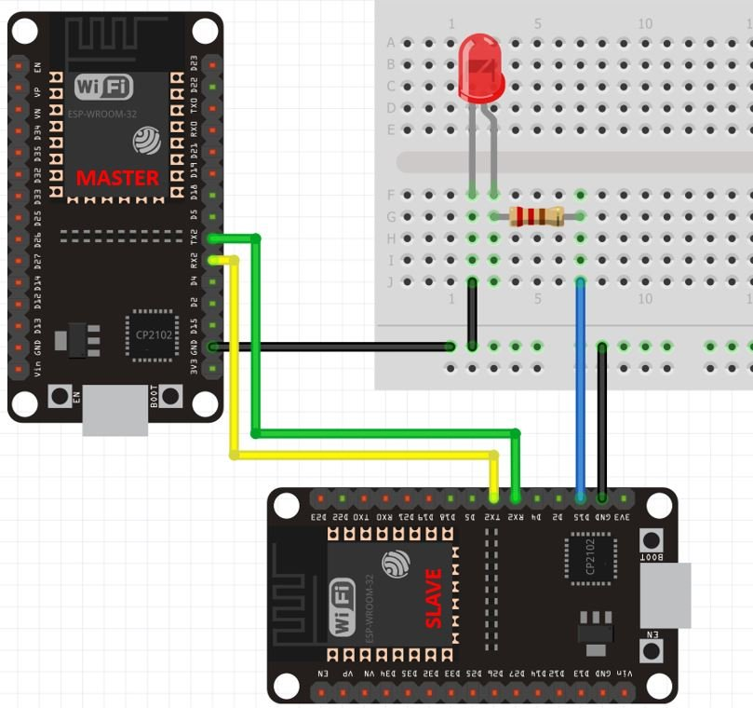

**Master ESP32 Arduino Sketch**

Open your Arduino IDE and go to File > New to open a new file. Copy the code given below and save it.

**CODE:**

**How the Code Works?**

Now let’s see how above code works.

First include the hardware serial library using #include files. This line includes the HardwareSerial.h library.

#include <HardwareSerial.h>

A serial object of the HardwareSerial library, named as “SerialPort” is declared here. We specify the UART port number as a parameter inside it. We are using UART2 in this case.

HardwareSerial SerialPort(2); // use UART2

Inside the setup() function, we will open the serial communication of port UART2 using SerialPort.begin (BaudRate, SerialMode, RX_pin, TX_pin).

void setup()

{

SerialPort.begin(15200, SERIAL_8N1, 16, 17);

}

Here the master will send the number 1 and 0 to the slave after every 5 seconds.

void loop()

{

SerialPort.print(1);

delay(5000);

SerialPort.print(0);

delay(5000);

}

**Slave ESP32 Arduino Sketch**

Open your Arduino IDE and go to File > New to open a new file. Copy the code given below and save it.

#include <HardwareSerial.h>

HardwareSerial SerialPort(2); // use UART2

char number = ' ';

int LED = 15;

void setup()

{

SerialPort.begin(15200, SERIAL_8N1, 16, 17);

pinMode(LED, OUTPUT);

}

void loop()

{

if (SerialPort.available())

{

char number = SerialPort.read();

if (number == '0') {

digitalWrite(LED, LOW);

}

if (number == '1') {

digitalWrite(LED, HIGH);

}

}

}

**How the Code Works?**

First include the hardware serial library.

#include <HardwareSerial.h>

A serial object of the HardwareSerial library, named as “SerialPort” is declared here. We specify the UART port number as a parameter inside it. We are using UART2 in this case.

HardwareSerial SerialPort(2); // use UART2

 A char variable called ‘number’ stores the data that the slave will receive from the master.

char number = ' ';

The LED is connected with the slave ESP32 GPIO15.

int LED = 15;

Inside the setup() function, we will open the serial communication of port UART2 using SerialPort.begin (BaudRate, SerialMode, RX_pin, TX_pin). Also, set the LED pin as an output pin using the pinMode() function. Specify the pin as the first parameter and the mode as the second parameter.

One important point to note here is that the baud rate of both ESP32 master and slave boards should be the same.

void setup()

{

SerialPort.begin(15200, SERIAL_8N1, 16, 17);

pinMode(LED, OUTPUT);

}

Inside the loop() function, we will check if data is present in the buffer. If some data is available, it is stored in variable ‘number.’ If the number is ‘0’, then turn the LED will be turned OFF. If the number is ‘1’, then the LED will be turned ON.

The master will send ‘1’ and ‘0’ with a delay of 5 seconds continuously to the slave. Hence, the LED will stay ON for 5 seconds and then OFF for 5 seconds.

void loop()

{

if (SerialPort.available())

{

char number = SerialPort.read();

if (number == '0') {

digitalWrite(LED, LOW);

}

if (number == '1') {

digitalWrite(LED, HIGH);

}

}

}

**Hardware Demonstration**

To see the demonstration, upload the master and sender codes to the two ESP32 boards. But, before uploading code, make sure to select the ESP32 Dev Module from Tools > Board and also select the correct COM port to which the board is connected from Tools > Port.

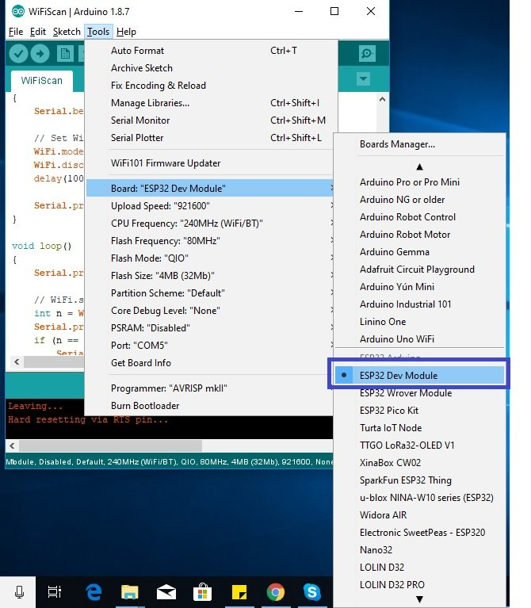

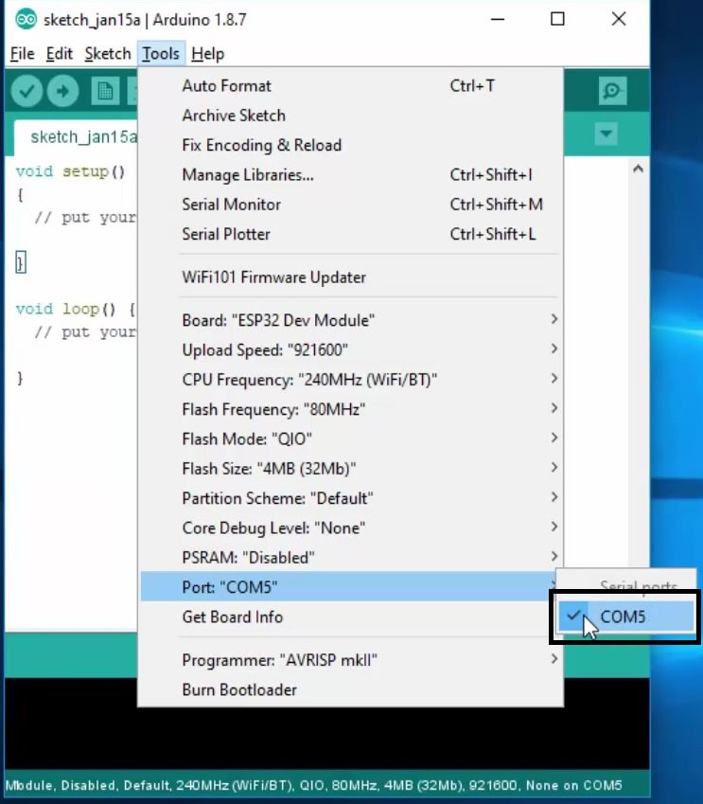

The LED will turn ON and stay ON for 5 seconds before turning OFF for 5 seconds. This continues as the master keeps on sending 1/0 to the slave.

**OUTPUT:**

**POST LAB:**

**INTERFERENCE & ANALYSIS**

**RESULT**

**Session 05: I2C Device Scanning using ESP 32**

**Date of the Session: / / Time of the Session: to**

**PREREQUISITE:**

* General idea of ESP32 board
* General idea of I2C

**PRE-LAB:**

1. Identify the pins on the ESP32 commonly used for I2C communication.
2. What is the purpose of the SDA and SCL pins in the I2C interface?
3. What is the purpose of I2C device scanning?
4. How does the ESP32 discover and identify I2C devices on the bus?
5. Describe the role of the Wire library in Arduino IDE for I2C communication.

**OBJECTIVE:**

To perform I2C Device Scanning using ESP 32

**REQUIRED COMPONENTS:**

* ESP32 development board
* MPU6050 3-axis accelerometer
* I2C LCD interface module
* Connecting Wires
* Breadboard

**CONNECTIONS:**



**CODE:**

**Test #1 Setup & Results**

For the first test, I’ve connected an MPU6050 IMU sensor to the SCL & SDA lines of I2C1 as you can see in the image down below. The I2C address for this slave device is 0x68 as stated in the datasheet.

We can change only one bit of that address so there could be 2 MPU6050 sensors on the same bus at maximum. Anyway, we should expect to see that address after running the example on the “Tera Term” serial terminal on my PC.

**OUTPUT:**

**POST LAB:**

**INTERFERENCE & ANALYSIS**

**RESULT**

**Test #2 Setup & Results**

In the second test, I’ve just added another I2C module to the bus lines which is the I2C_LCD interface IO expander (PCF8574T). This module has an I2C slave address of 0x27 as a default address if no solder bridge on the module’s board is touched at all.

You can still play around with those bridges to change the device address to allow many I2C_LCD devices on the same bus

**Session 06: Testing of I2S microphone using ESP 32**

**Date of the Session: / / Time of the Session: to**

**PREREQUISITE:**

* General idea of ESP32 board
* General idea of I2S peripherals

**PRE-LAB:**

1. What is I2S protocol and where it is used?
2. Identify the pins on the ESP32 commonly used for I2S microphone modules
3. What is the purpose of SD, SCK and WS connection pins in the I2S microphone module?
4. How does the ESP32 discover and identify I2C devices on the bus?
5. Describe the role of the I2S library in Arduino IDE for I2S microphone.

**OBJECTIVE:**

To display the audio waveforms from the microphone using the Serial Plotter through ESP32 in Arduino IDE.

**REQUIRED COMPONENTS:**

* ESP32 development board
* INMP441 Microphone Module
* Connecting Wires
* Breadboard

**CONNECTIONS:**

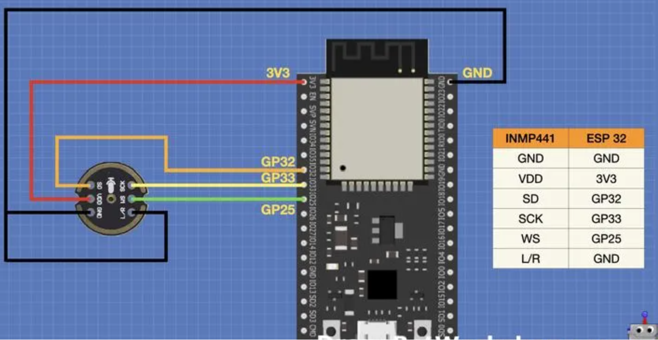

**CODE:**

**How the Code works:**

We start by including the ESP32 I2S driver.

We then define the connections to our microphone. If you wish, you can rewire the microphone and change the code here.

The ESP32 has two internal I2S processors. We will be using the first one, I2S Port 0.  We also define the length of an input data buffer.

Next, we have a function called *i2s_install*, which sets up the I2S port parameters.

A second function, *i2s_setpin*, sets up the physical connection to the I2S device, which in our case is the microphone module.

In the Setup, we set up our serial connection, as we will be using the Serial Plotter to display our audio waveforms.  We then cal our two functions to set up the I2S port, and then start it with a third built-in function.

Our Loop starts with a “false” print statement, this just causes two constants to be printed to steady the reading on the Serial Plotter, which otherwise will dynamically change its Y-axis scale.

We then read data from the module and place it in our data buffer. If the data is good, we read it out and display it on the Serial Plotter

**OUTPUT:**

**POST LAB:**

**INTERFERENCE & ANALYSIS**

**RESULT**

**Session 07: Finding the Default SPI pins of ESP 32**

**Date of the Session: / / Time of the Session: to**

**PREREQUISITE:**

* General idea of ESP32 board
* General idea of SPI Pins, Multiple SPI Bus Interfaces, and Peripherals (Arduino IDE)

**PRE-LAB:**

1. What is the role of SPI in the ESP32 and how is it utilized within the microcontroller?
2. How do SPI pins (CLK, MOSI, MISO, CS) facilitate communication with peripheral devices?
3. What is the default GPIO pin assignments for the SPI interface (CLK, MOSI, MISO, CS) on the ESP32?
4. Can the default SPI pins on the ESP32 be reconfigured or changed?

**OBJECTIVE:**

To perform SPI communication using ESP 32

**REQUIRED COMPONENTS:**

* ESP32 development board
* Connecting Wires
* Breadboard

**THEORY:**

SPI stands for **S**erial **P**eripheral **I**nterface, and it is a synchronous serial data protocol used by microcontrollers to communicate with one or more peripherals. For example, your ESP32 board communicating with a sensor that supports SPI or with another microcontroller.

In an SPI communication, there is always a **controller**(also called master) that controls the **peripheral**devices (also called slaves). Data can be sent and received simultaneously. This means that the master can send data to a slave, and a slave can send data to the master at the same time.

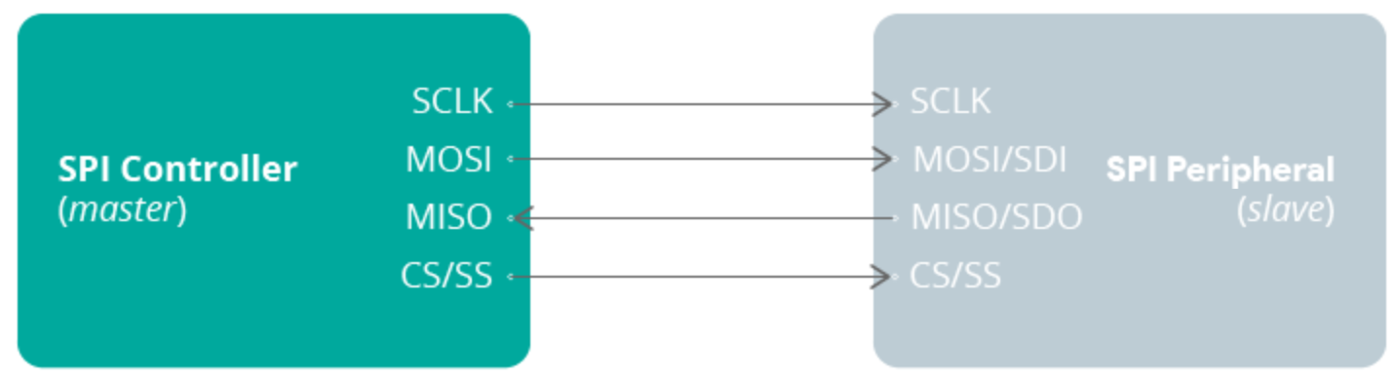

You can have only one master, which will be a microcontroller (the ESP32), but you can have multiple slaves. A slave can be a sensor, a display, a microSD card, etc., or another microcontroller. This means you can have an ESP32 connected to multiple sensors, but the same sensor can’t be connected to multiple ESP32 boards simultaneously.

**SPI Interface:**

For SPI communication you need four lines:

* **MISO**: Master In Slave Out
* **MOSI**: Master Out Slave In
* **SCK**: Serial Clock
* **CS**/**SS**: Chip Select (used to select the device when multiple peripherals are used on the same SPI bus)

On a slave-only device, like sensors, displays, and others, you may find a different terminology:

* **MISO**may be labelled as **SDO** (Serial Data Out)
* **MOSI**may be labelled as **SDI** (Serial Data In)

**ESP32 SPI Peripherals:**

The ESP32 integrates 4 SPI peripherals: SPI0, SPI1, SPI2 (commonly referred to as **HSPI**), and SPI3 (commonly referred to as **VSPI**).

SP0 and SP1 are used internally to communicate with the built-in flash memory, and you should not use them for other tasks. You can use **HSPI**and **VSPI**to communicate with other devices. HSPI and VSPI have independent bus signals, and each bus can drive up to three SPI slaves.

**ESP32 Default SPI Pins:**

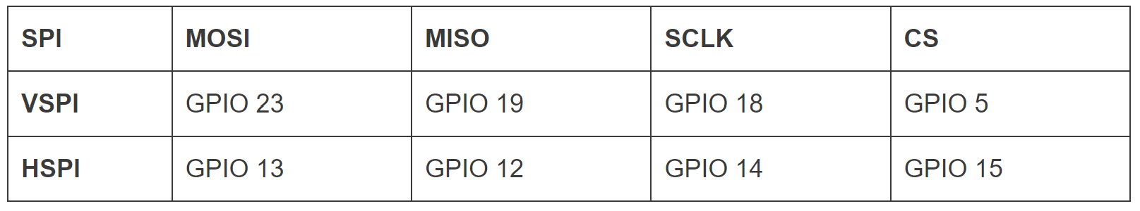

**CODE:**

**Note:** make sure you select the board you’re using in Tools > Board, otherwise, you may not get the right pins.

After uploading the code, open the Serial Monitor, RST your board and you’ll see the SPI pins.

**OUTPUT:**

**POST LAB:**

**INTERFERENCE & ANALYSIS**

**RESULT**

**Session 8: Interfacing MCP 2515 CAN controller with ESP 32**

**Date of the Session: / / Time of the Session: to**

**PREREQUISITE:**

* General idea of ESP32 board
* General idea of CAN Bus communication with MCP2515 module

**PRE-LAB:**

1. What is CAN (Controller Area Network) Bus communication, and what makes it suitable for use in various applications?
2. How does CAN Bus differ from other communication protocols like SPI or I2C?
3. What are the primary functions of the ESP32 and MCP2515 within the CAN Bus communication setup?
4. How does the MCP2515 interface with the ESP32 for CAN Bus communication?

**OBJECTIVE:**

To interface CAN controller MCP2515 module with ESP 32

**REQUIRED COMPONENTS:**

* ESP32
* MCP2515 module
* Connecting wires

**CIRCUIT:**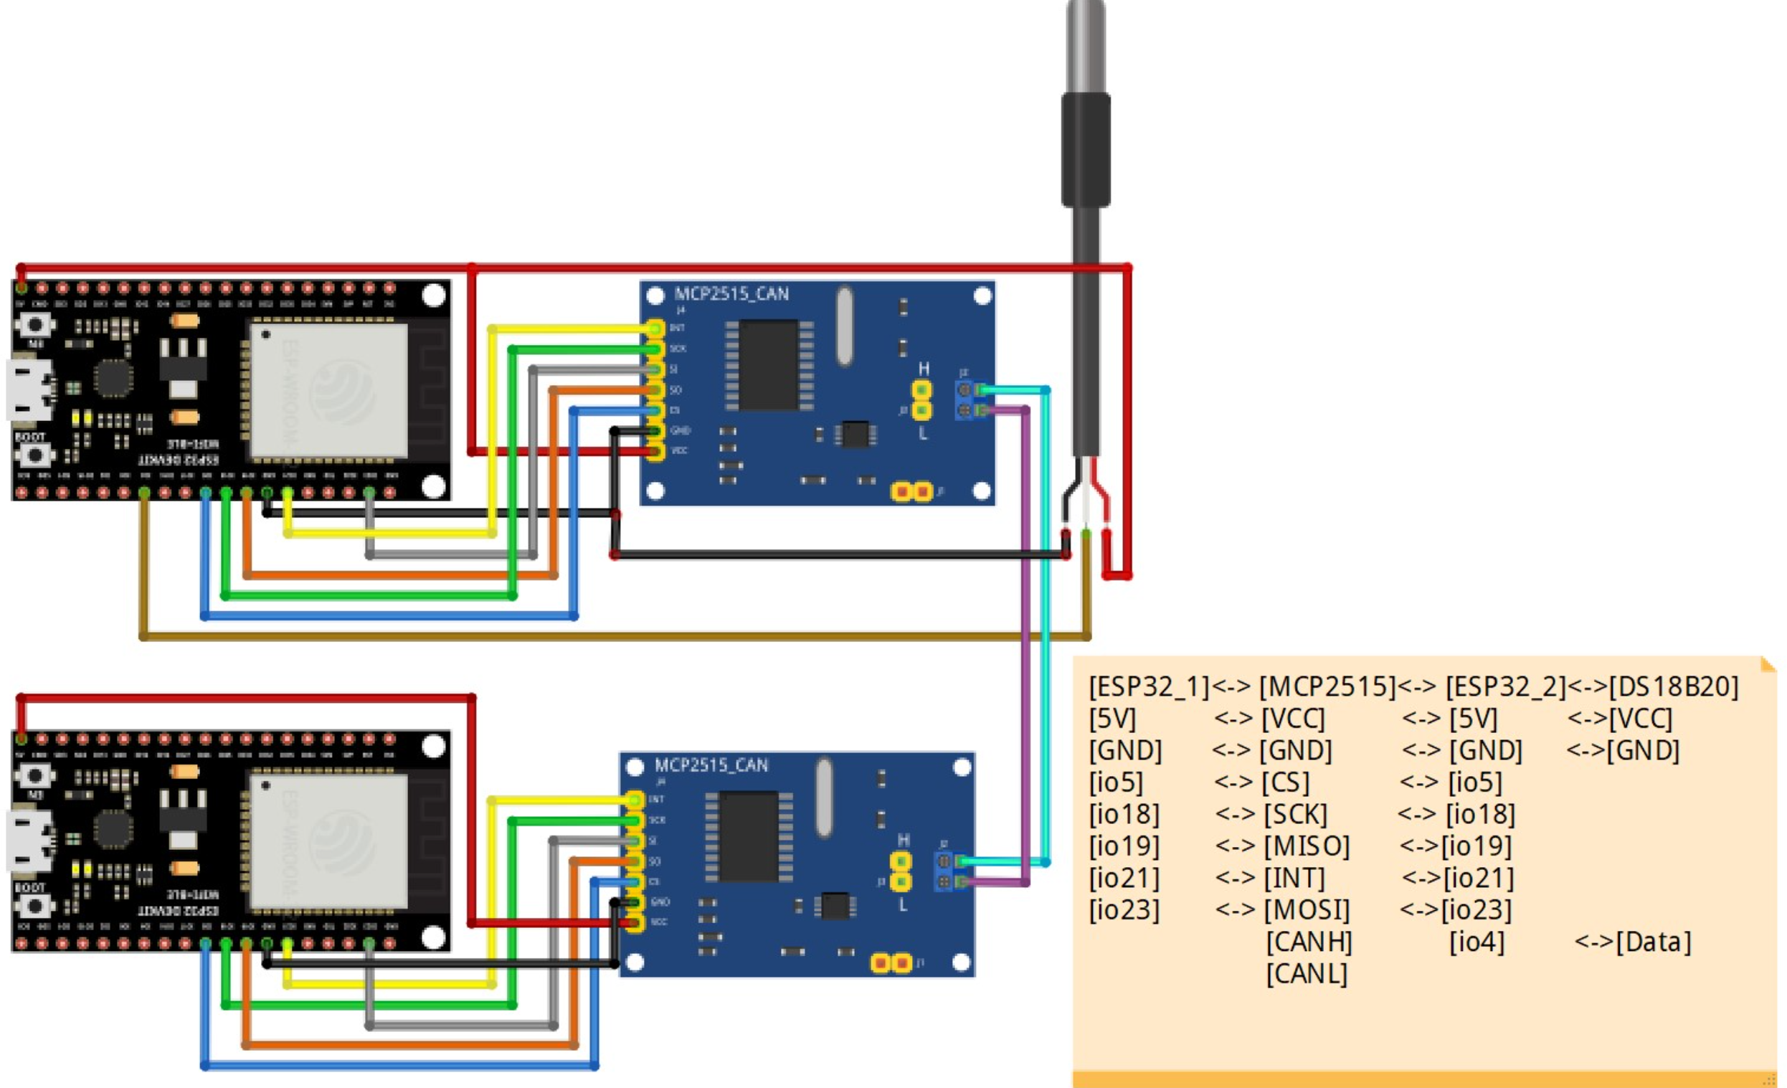

**CODE:**

**OUTPUT:**

**POST LAB:**

**INTERFERENCE & ANALYSIS**

**RESULT**

**Session 9: ADC read using LED dimmer using ESP 32**

**Date of the Session: / / Time of the Session: to**

**PREREQUISITE:**

* General idea of ESP32 board
* General idea of ESP32 Analog Input Read Potentiometer

**PRE-LAB:**

1. What is ADC, and how does it convert an analog signal to a digital value in microcontrollers like the ESP32?
2. What are the characteristics and capabilities of the ADC in the ESP32 microcontroller?
3. How can Pulse Width Modulation (PWM) be used to control the brightness of an LED?
4. How would you physically connect an LED to the ESP32 to implement LED dimming using PWM?
5. How can the analog values read from the ADC be mapped to the PWM range for controlling LED brightness?

**OBJECTIVE:**

To create an LED dimmer using an ESP32 and a potentiometer to control the LED brightness.

**REQUIRED COMPONENTS:**

* ESP32 development board
* Potentiometer
* LED
* 1 kΩ Resistor
* Breadboard

**CIRCUIT:**

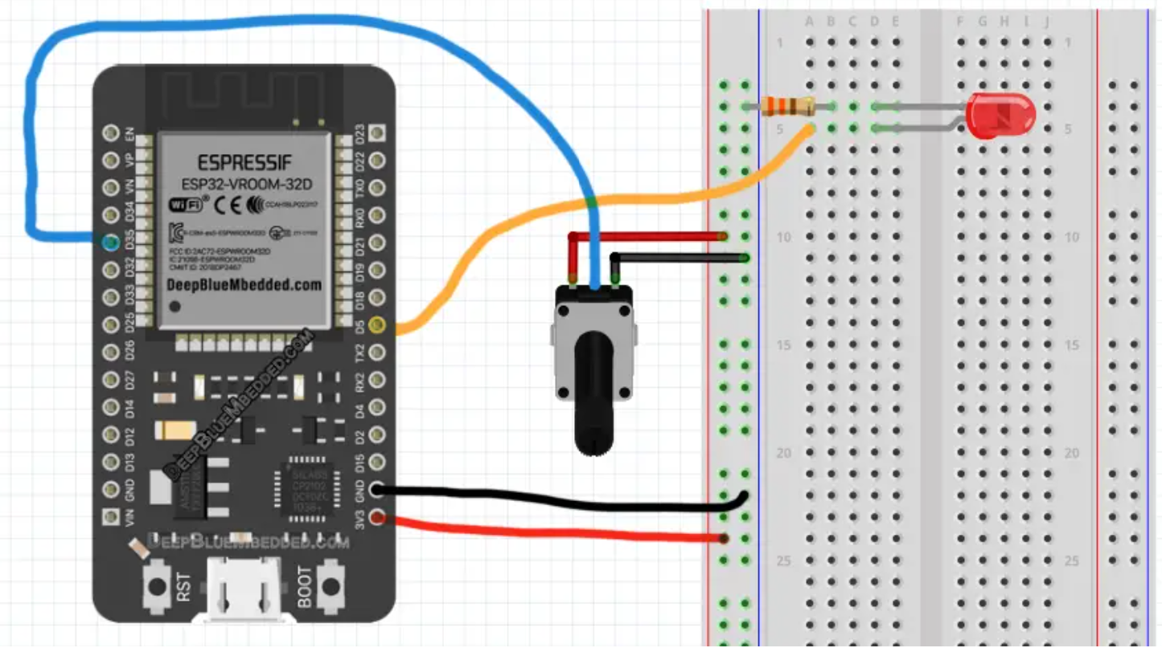

**ESP32 Analog Input Read Potentiometer (LED Dimmer Code Example):**

We start with defining and attaching The PWM GPIO pin. The pin I’ll be using a PWM pin is GPIO5 in this example.

Then, we’ll be configuring the PWM Channel’s frequency (1kHz) & resolution (12-Bits to be similar to the ADC_Result). And in the main loop() function, we’ll read the ESP32 ADC analog input (potentiometer – GPIO35 pin), and write the result to the PWM duty cycle.

**CODE:**

**OUTPUT:**

**POST LAB:**

**INTERFERENCE & ANALYSIS**

**RESULT**

**Session 10: Observation of Analog output from ESP 32**

**Date of the Session: / / Time of the Session: to**

**PREREQUISITE:**

* General idea of ESP32 board
* General idea of ESP32 DAC Direct Voltage Output Mode

**PRE-LAB:**

1. How does Pulse Width Modulation (PWM) in the ESP32 simulate analog output?
2. What factors influence the resolution and accuracy of analog-like output using PWM on the ESP32?
3. If using PWM to control an LED's brightness, how does adjusting the PWM duty cycle impact the perceived brightness of the LED?
4. How would you observe and measure the analog-like output generated by the ESP32, such as using an oscilloscope or a multimeter?
5. What aspects of the signal (frequency, duty cycle) would you examine during observation?

**OBJECTIVE:**

To generate constant analog output voltage using ESP 32 DAC

**REQUIRED COMPONENTS:**

* ESP32 development board
* Connecting Wires
* Breadboard
* Voltmeter

**THEORY:**

**ESP32 Analog Output DC Voltage:**

You can typically use the ESP32 built-in DAC to generate an analog output DC voltage which will remain constant until you update the value of the DAC buffer register. The digital input value is 8-Bit because the ESP32 DAC is 8-Bit in resolution and the output is an analog voltage level on the DAC_CHANNEL pin. Use the following formula to find out the analog output that corresponds to any digital input value.

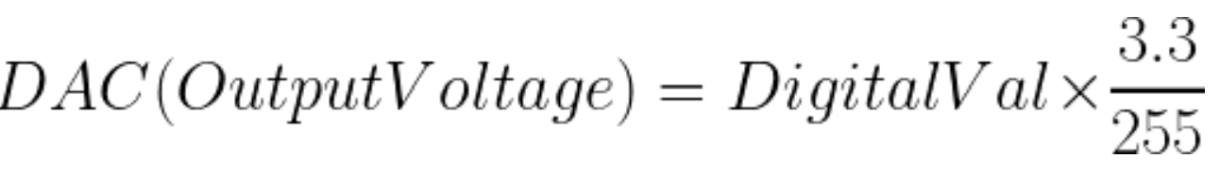

**CIRCUIT:**

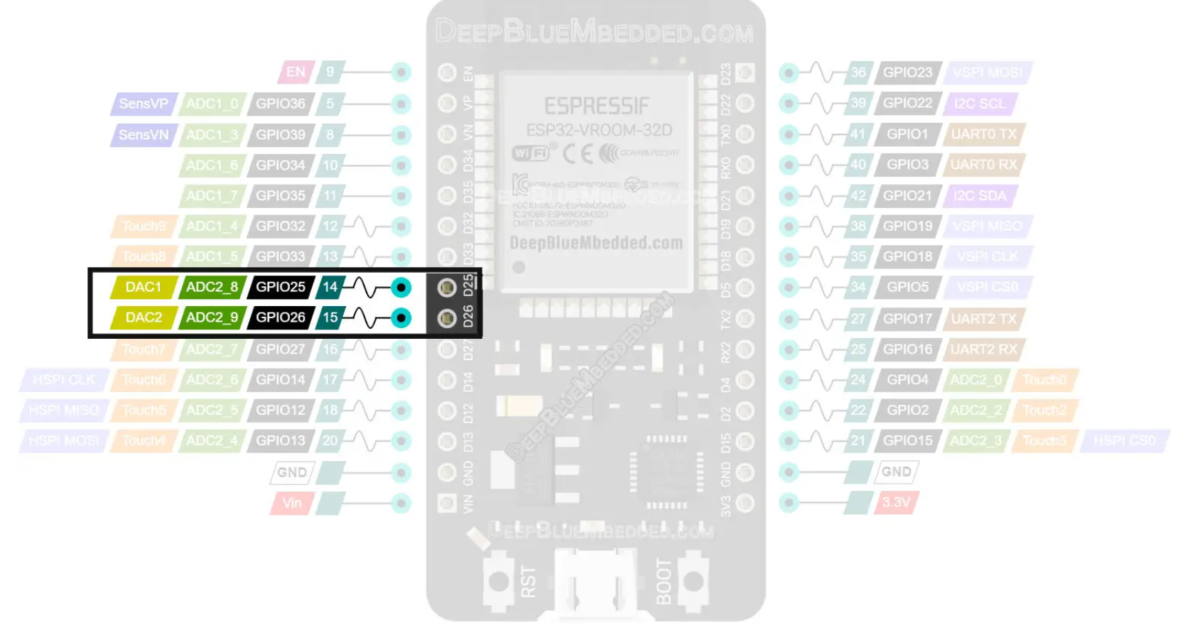

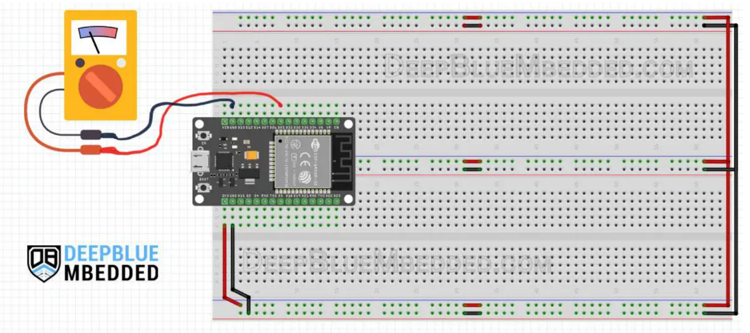

**CODE:**

**OUTPUT:**

**POST LAB:**

**INTERFERENCE & ANALYSIS**

**RESULT**

**Session 11: Sine Wave Generation using ESP 32**

**Date of the Session: / / Time of the Session: to**

**PREREQUISITE:**

* General idea of ESP32 board
* General idea of sinusoidal waveform generation with controllable frequency, amplitude, and phase.

**PRE-LAB:**

1. What is a sine wave, and why is it a fundamental waveform in signal processing and electronics?
2. Does the ESP32 have built-in hardware support for generating analog signals like a sine wave, or is it primarily capable of digital signal generation?
3. How would you observe and measure the generated sine wave's characteristics, such as using an oscilloscope or a multimeter?
4. How does the resolution of the digital output (bits of resolution) impact the quality of the generated sine wave?

**OBJECTIVE:**

* To generate sine wave with ESP32 using the built-in DAC feature.
* To obtain clean sinusoidal waveform with controllable frequency, amplitude, and phase.

**REQUIRED COMPONENTS:**

* ESP32 development board
* Connecting Wires
* Digital Oscilloscope

**CIRCUIT:**

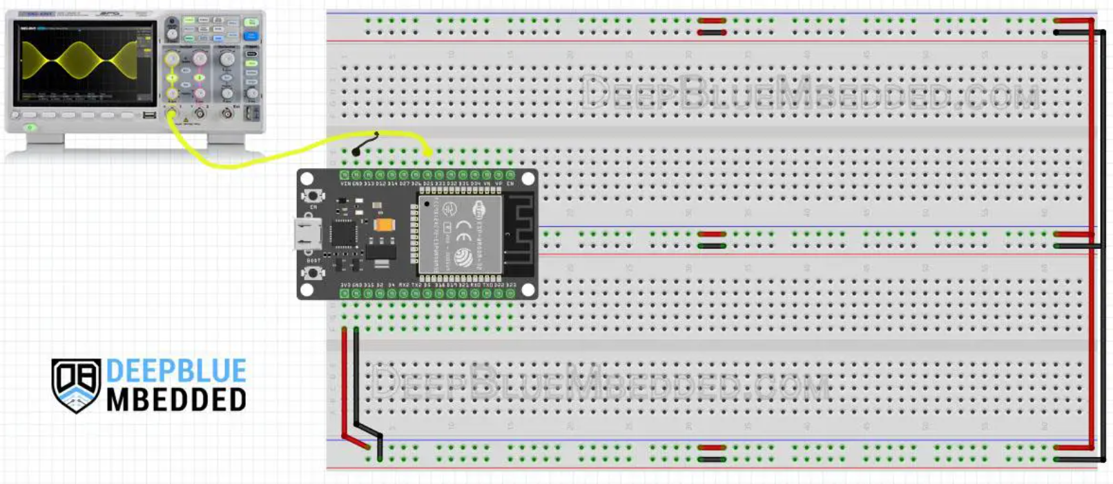

**CODE:**

**OUTPUT:**

**POST LAB:**

**INTERFERENCE & ANALYSIS**

**RESULT**

**Session 12: Testing of EEPROM memory of ESP 32**

**Date of the Session: / / Time of the Session: to**

**PREREQUISITE:**

* General idea of ESP32 board
* General idea of ESP 32 EEPROM memory

**PRE-LAB:**

1. What is EEPROM, and what distinguishes it from other types of memory like RAM and Flash memory?
2. What are the characteristics and limitations of the EEPROM emulation on the ESP32?
3. What is the typical size or capacity of the EEPROM space available on the ESP32 for data storage?
4. How would you verify the accuracy and consistency of data read from and written to the EEPROM?

**OBJECTIVE:**

To test the EEPROM memory of ESP 32 by saving the last LED state

**REQUIRED COMPONENTS:**

* ESP32 development board
* Connecting Wires
* Breadboard
* Push button
* LED
* Resistor

**CIRCUIT:**

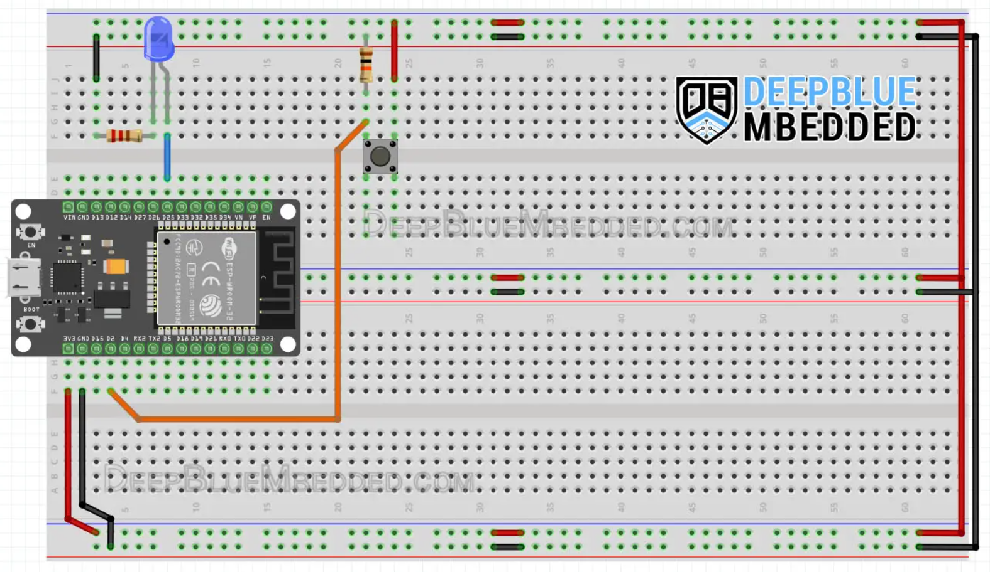

**CODE:**

**Code Explanation:**  
The code example does simply read the button input pin and debounces it to make sure it’s not picking up any noise. And toggle the LED if the button is actually pressed. The LED toggle event does also a write operation to the eeprom_address location and saves the current ledState in the FLASH memory.

We start by including the EEPROM.h Library

// Include The EEPROM.h Library To Read & Write To The FLASH Memory

#include <EEPROM.h>

Then, we define the needed memory size of EEPROM which is only 1 byte. And also define the GPIO pins we’ll be using.

// Define The Number of Bytes You Need

#define EEPROM_SIZE 1

// Define The LED Output GPIO Pin & Button Input GPIO Pin

#define LED_GPIO 25

#define BTN_GPIO 2

We also define some global variables to save the LED state, and button state, and perform the button debouncing logic.

// Global Variables For Button Reading & Debouncing

int ledState = LOW;

int btnState = LOW;

int lastBtnState = LOW;

int lastDebounceTime = 0;

int debounceDelay = 50;

int eeprom_address = 0;

**setup()**

in the setup() function, we initialize serial communication for debugging, the pin modes, and the EEPROM with the pre-defined size.

Serial.begin(115200);

pinMode(LED_GPIO, OUTPUT);

pinMode(BTN_GPIO, INPUT);

EEPROM.begin(EEPROM_SIZE);

We also read the last saved LED state from the FLASH memory and apply it to the LED output. This happens only at startup, hence it’s done in setup() function.

ledState = EEPROM.read(eeprom_address);

digitalWrite(LED_GPIO, ledState);

**loop()**

in the loop() function, it’s mostly about reading the button and debouncing it. Once, it’s clear that the button is held HIGH and it’s not a noise, we take the LED toggle action + saving the current LED state to the EEPROM (Flash Memory).

int reading = digitalRead(BTN_GPIO);

if (reading != lastBtnState)

{

lastDebounceTime = millis();

}

if ((millis() - lastDebounceTime) > debounceDelay)

{

if (reading != btnState)

{

btnState = reading;

if (btnState == HIGH)

{

ledState = !ledState;

digitalWrite(LED_GPIO, ledState);

EEPROM.write(eeprom_address, ledState);

EEPROM.commit();

Serial.println("State Changed & Saved To FLASH!");

}

}

}

lastBtnState = reading;

**OUTPUT:**

**POST LAB:**

**INTERFERENCE & ANALYSIS**

**RESULT**

**Session 13: Scanning Bluetooth Devices using ESP 32**

**Date of the Session: / / Time of the Session: to**

**PREREQUISITE:**

* General idea of ESP32 board
* General idea of ESP32 Bluetooth Classic Vs ESP32 Bluetooth Low Energy (BLE)

**PRE-LAB:**

1. What Bluetooth capabilities does the ESP32 offer, and which Bluetooth protocols or versions does it support?
2. How does the ESP32 detect and identify Bluetooth devices within its range?
3. How does the ESP32 handle potential errors or issues during Bluetooth device scanning?
4. Once Bluetooth devices are scanned, how is the information about discovered devices collected and retrieved in ESP32-based code?

**OBJECTIVE:**

To perform scanning of surrounding Bluetooth devices using ESP 32

**REQUIRED COMPONENTS:**

* ESP32 development board

**THEORY:**

**ESP32 Bluetooth Scanner:**

The ESP32 Bluetooth Scanner is also called Device Discovery which is a very simple application that runs either Synchronously or Asynchronously and searches for all surrounding Bluetooth devices and report their number, names, and MAC addresses. Then you can choose which device to connect to afterward or keep rescanning in case no device is found.

As stated earlier the ESP32 Bluetooth Scanner can run Synchronously (Blocking) which means it’ll keep searching until completion and the whole application will be stuck until the synchronous function call is executed till completion. It’s not generally a bad thing to do as it may be required in some applications.

In order to perform Bluetooth Scanning for Device Discovery (Synchronously), use the SerialBT.discover(BT_DISCOVER_TIME) function. For Asynchronous scanning, you should use SerialBT.discoverAsync() function instead.

**CODE:**

**OUTPUT:**

**POST LAB:**

**INTERFERENCE & ANALYSIS**

**RESULT**

**Session 14: Duplex Bluetooth Communication Between ESP 32 and Android Phone**

**Date of the Session: / / Time of the Session: to**

**PREREQUISITE:**

* General idea of ESP32 board
* General idea of ESP32 Bluetooth send and receive data

**PRE-LAB:**

1. What is duplex communication in the context of Bluetooth, and why is it essential for bidirectional data exchange?
2. What are the Bluetooth capabilities of the ESP32, particularly concerning its ability to function as a Bluetooth device and communicate with other devices like smartphones?
3. What communication protocols or methods can be used for exchanging data between the ESP32 and an Android app over Bluetooth?
4. What are potential challenges or issues that might arise during Bluetooth communication between the ESP32 and the Android phone?

**OBJECTIVE:**

To create an ESP32 Bluetooth Receiver Device and use Android Smartphone to control it over Bluetooth.

**REQUIRED COMPONENTS:**

* ESP32 development board
* Android mobile phone
* Serial Bluetooth Terminal Android app
* Breadboard
* Connecting wires

**CIRCUIT:**

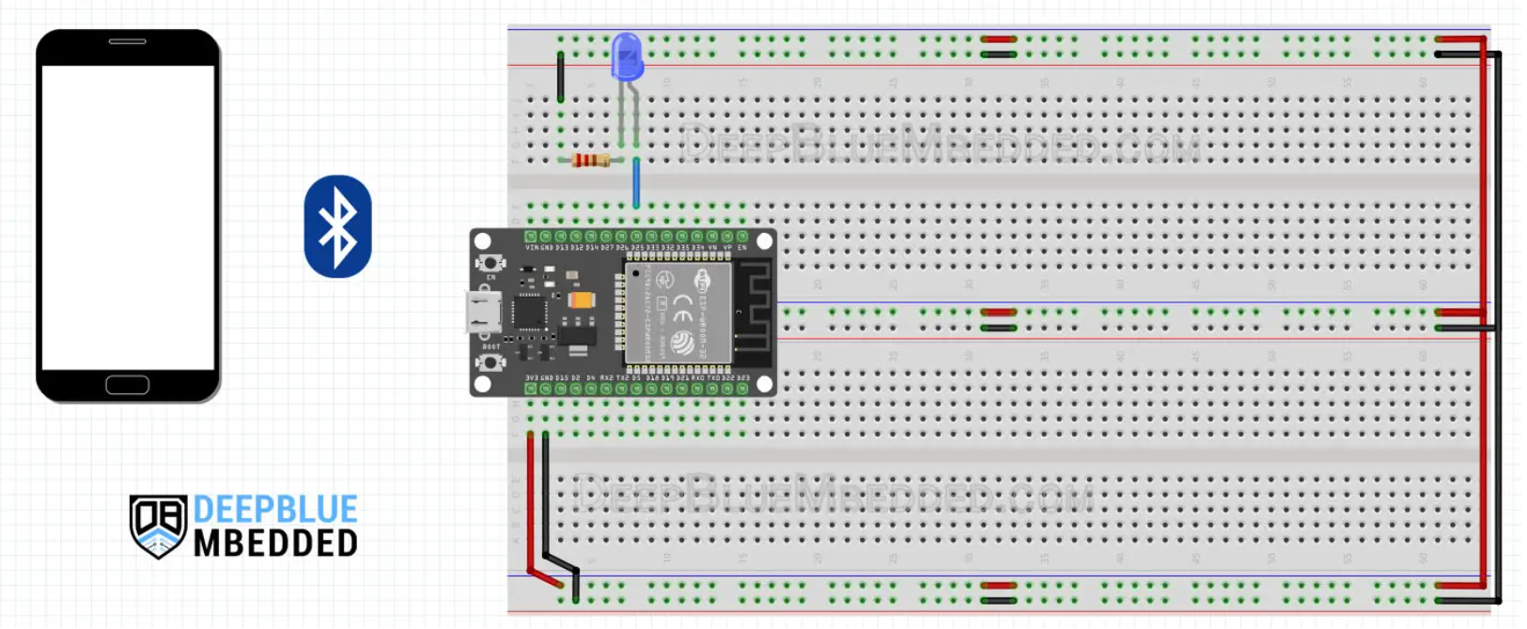

**CODE:**

**Code Explanation:**

First of all, include the BluetoothSerial library and check if Bluetooth is properly enabled or not.

#include "BluetoothSerial.h"

#if !defined(CONFIG_BT_ENABLED) || !defined(CONFIG_BLUEDROID_ENABLED)

#error Bluetooth is not enabled! Please run `make menuconfig` to and enable it

#endif

#if !defined(CONFIG_BT_SPP_ENABLED)

#error Serial Bluetooth not available or not enabled. It is only available for the ESP32 chip.

#endif

Create an instance of the BluetoothSerial called SerialBT, and define a GPIO pin for LED output which is going to be GPIO25 pin.

// LED GPIO Pin Definition

#define LED_GPIO 25

// Bluetooth Serial Object (Handle)

BluetoothSerial SerialBT;

Set a PIN code for the ESP32 slave device “1234” and a name “ESP32-BT-Slave“. Create a variable “RxByte” to hold the last received byte of data and an array “RxBuffer” to store the incoming data byte by byte.

// ESP32 Bluetooth (Slave) Device Information

const char *pin = "1234"; // Change this to more secure PIN.

String device_name = "ESP32-BT-Slave";

// Bluetooth Received Byte & Message Buffer Array

String RxBuffer = "";

char RxByte;

setup()

in the setup() function, set the LED pin to output

pinMode(LED_GPIO, OUTPUT);

Start serial communication for monitoring & debugging

Serial.begin(115200);

Start the Bluetooth device with the given name and PIN code.

SerialBT.begin(device_name); //Bluetooth device name

Serial.printf("The device with name \"%s\" is started.\nNow you can pair it with Bluetooth!\n", device_name.c_str());

SerialBT.setPin(pin);

Serial.println("Using PIN");

loop()

In the loop() function, read the incoming data bytes and push them to the RxBuffer array.

// Read The Received Bytes & Add Them To Message (RxBuffer) Array

if (SerialBT.available()){

RxByte = SerialBT.read();

if (RxByte != '\n'){

RxBuffer += String(RxByte);

}

else{

RxBuffer = "";

}

Serial.write(RxByte);

}

Then check the received message buffer (RxBuffer) array, if it’s “led_on” turn the LED ON, else if it was “led_off” turn the LED OFF. Otherwise, don’t take any action. And keep repeating.

// Check The Received Message & Update Output LED State

if (RxBuffer =="led_on"){

digitalWrite(LED_GPIO, HIGH);

}

else if (RxBuffer =="led_off"){

digitalWrite(LED_GPIO, LOW);

}

**OUTPUT:**

**POST LAB:**

**INTERFERENCE & ANALYSIS**

**RESULT**

**Session 15: Scanning of Wi-Fi Network using ESP 32**

**Date of the Session: / / Time of the Session: to**

**PREREQUISITE:**

* General idea of ESP32 board
* Set up and configure the ESP32 to scan for WiFi networks

**PRE-LAB:**

1. What functionalities does the ESP32 offer for scanning nearby Wi-Fi networks?
2. How does the ESP32 detect and gather information about available Wi-Fi networks within its range?
3. Outline the basic structure or algorithm of the code required to initiate Wi-Fi network scanning using the ESP32.

**OBJECTIVE:**

To scan the available WiFi networks using the ESP 32 board

**REQUIRED COMPONENTS:**

* ESP32 development board

**CODE:**

**OUTPUT:**

**POST LAB:**

**INTERFERENCE & ANALYSIS**

**RESULT**

**RESULT:**

**Session 16: Signal Strength Identification of Wi-Fi Network**

**using ESP 32**

**Date of the Session: / / Time of the Session: to**

**PREREQUISITE:**

* General idea of ESP32 board
* General idea of get ESP32 WiFi Connection Status

**PRE-LAB:**

1. How does the ESP32 detect and assess the signal strength of available Wi-Fi networks within its range?
2. What metrics or units are commonly used to represent Wi-Fi signal strength, such as dBm (decibel-milliwatts) or RSSI (Received Signal Strength Indicator)?
3. Can the ESP32 process or filter Wi-Fi network signal strength data to focus on specific criteria (e.g., strong signals, weak signals)?
4. How would you verify the correlation between signal strength values and the actual signal quality or network performance?

**OBJECTIVE:**

To get and print the RSSI (Received Signal Strength Indicator) for the WiFi network

**CODE:**

**Note:**

RSSI is an estimated measure of the WiFi signal strength for a specific network (router or access point). The return value has the following form and unit (-x dBm). Which means a lower absolute value indicates a more powerful connection. Here’s how to judge the RSSI value and decide on the signal strength rating:

RSSI > -30 dBm: Amazing!

RSSI < -55 dBm: Very good signal

RSSI < -67 dBm: Fairly good

RSSI < -70 dBm: Okay

RSSI < -80 dBm: Not good

RSSI < -90 dBm: Extremely weak signal (unusable)

**OUTPUT:**

**POST LAB:**

**INTERFERENCE & ANALYSIS**

**RESULT**

**Session 17: Get and Set MAC address of ESP 32**

**Date of the Session: / / Time of the Session: to**

**PREREQUISITE:**

* General idea of ESP32 board
* General idea of get ESP32 WiFi Connection Status

**PRE-LAB:**

1. How is a MAC address formatted, and what information does it contain?
2. Where is the MAC address stored in the ESP32's hardware, and how is it accessed programmatically?
3. Can the MAC address of an ESP32 be changed or set programmatically?
4. Are there any specific scenarios or applications where changing the MAC address might be necessary or beneficial?

**OBJECTIVE:**

To learn how to Get the ESP32 MAC Address and how to Change the ESP32 MAC Address in Arduino IDE

**Get ESP32 MAC Address:**

The MAC address of the ESP32 can be easily obtained using the WiFi library that’s already built into the Arduino Core for ESP32. You need to call the WiFi.macAddress() function that returns the MAC address in the form of a 6-byte array formatted as a string.

**CODE:**

**Change ESP32 MAC Address:**

To change the ESP32 MAC address in Arduino IDE, you can use the esp_wifi_set_mac()function from the esp_wifi.h library. Which takes the WiFi mode and the MAC address array as arguments.

**CODE:**

**OUTPUT:**

**POST LAB:**

**INTERFERENCE & ANALYSIS**

**RESULT**

**Session 18: Get the IP address of ESP 32**

**Date of the Session: / / Time of the Session: to**

**PREREQUISITE:**

* General idea of ESP32 board
* General idea of getting the IP of ESP 32

**PRE-LAB:**

1. What is an IP address?
2. Explain the purpose of subnet masks.
3. How does the ESP32 handle networking tasks?
4. What is the significance of SSID and password in WiFi configuration?

**OBJECTIVE:**

To get static IP address of ESP 32

**REQUIRED COMPONENTS:**

* ESP32 development board
* Connecting Wires
* Breadboard

**CODE:**

**OUTPUT:**

**POST LAB:**

**INTERFERENCE & ANALYSIS**

**RESULT**

**Session 19: Assign Static IP address for ESP 32**

**Date of the Session: / / Time of the Session: to**

**PREREQUISITE:**

* General idea of ESP32 board
* General idea of assigning static IP address for ESP 32

**PRE-LAB:**

1. What specific parameters are required to configure a static IP address
2. How would you incorporate the necessary parameters (IP address, subnet mask, gateway, DNS server) into the ESP32 code?
3. How are these parameters set or defined within the ESP32 code?
4. What are potential benefits and drawbacks of using a static IP address on the ESP32 in terms of network stability and interoperability?

**OBJECTIVE:**

To set a static IP address for ESP32

**REQUIRED COMPONENTS:**

* ESP32 development board
* Connecting Wires
* Breadboard

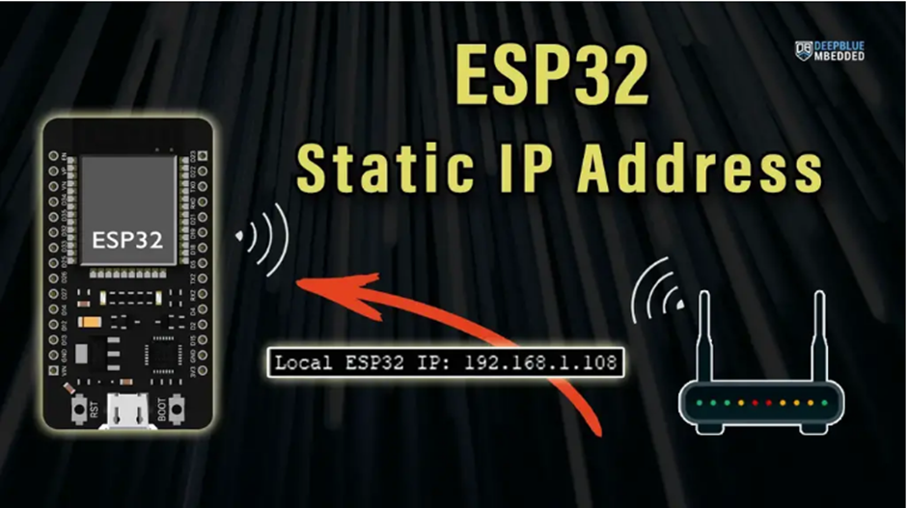

**CODE:**

**OUTPUT:**

**POST LAB:**

**INTERFERENCE & ANALYSIS**

**RESULT**

**Session 20: Change the host name of ESP 32**

**Date of the Session: / / Time of the Session: to**

**PREREQUISITE:**

* General idea of ESP32 board
* What is the purpose of changing hostname in ESP 32
* Why to change the WiFi network credentials, SSID, PWD and Host name

**PRE-LAB:**

1. What is a hostname in networking, and how is it used to identify devices within a network?
2. What parameters or information are required to configure or change the hostname of an ESP32 device?
3. How does changing the hostname affect the ESP32's identification and interaction within the network environment?
4. How would you incorporate the necessary code to modify the hostname in an ESP32-based program?

**OBJECTIVE:**

To get the ESP32 hostname and also to modify custom hostname in Arduino IDE.

**REQUIRED COMPONENTS:**

* ESP32 development board
* Connecting Wires
* Breadboard

**ESP32 Get HostName:** The ESP32 Hostname is the device name that other WiFi devices will see on the network. You can get the ESP32 hostname by calling the WiFi.getHostname() function. Here is an example code for getting and printing the ESP32 WiFi hostname.

Serial.println(WiFi.getHostname());

Here is the generic (default) hostname for my ESP32 board as seen by my router.

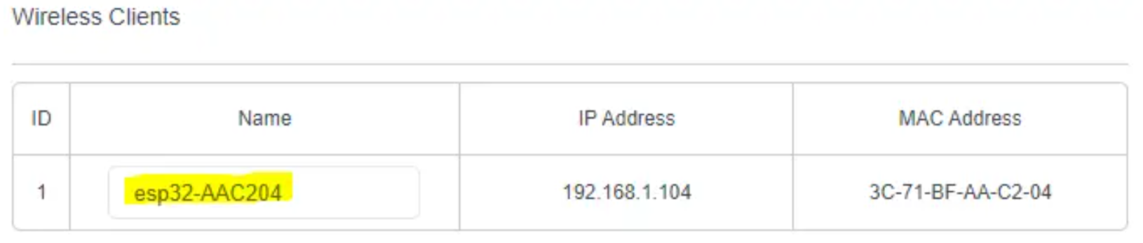

**ESP32 HostName Change:**

To change the ESP32 hostname, you need to call the WiFi.setHostname() function before calling WiFi.mode() and then WiFi.begin() in this exact same order.

**CODE:**

**OUTPUT:**

**POST LAB:**

**INTERFERENCE & ANALYSIS**

**RESULT**

**Session 21: Controlling the GPIO pins in ESP32 using Touch Inputs**

**Date of the Session: / / Time of the Session: to**

**PREREQUISITE:**

* General idea of ESP32 board
* Understanding of touch sensor principles and how they interface with microcontrollers

**PRE-LAB:**

1. What type of cable should be used for ESP32? What parameters or information are required to configure or change the hostname of an ESP32 device?
2. Specify ROM size of ESP32?
3. Mention the software which is to be installed in the laptop for the ESP32 board?
4. What is the operating voltage of the GPIO pins in ESP32?

**OBJECTIVE:**

To interface MPU6050 module with ESP32 and WEBSERVER using Arduino IDE Programming.

**REQUIRED COMPONENTS:**

* ESP32 development board
* Connecting cable
* Connecting Wires

**CONNECTION:**

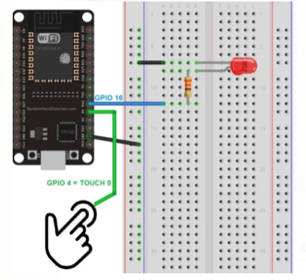

**CODE:**

**Precautions:**

1. Use insulation tools while you connect the Circuit.
2. Wear Good Insulating Shoes.
3. Avoid contacting circuits with wet hands or wet materials.
4. Maintain a work space clear of extraneous material such as books, papers, and clothes.
5. Be careful while connecting any actuators in 230V AC Mains.

**OUTPUT:**

**POST LAB:**

**INTERFERENCE & ANALYSIS**

**RESULT**